12-port full Gigabit AI smart POE switch
The full Gigabit smart POE switch is an independent innovative research and development design by Tianbo Communication specifically to meet the POE++ power supply needs. It adopts the latest high-speed Ethernet switching chip and ultra-high backplane bandwidth design. It has extremely fast data processing capabilities and improves smooth data transmission performance. AI intelligent watchdog function, support VLAN, support 10M bandwidth transmission; specifications to meet the needs of application scenarios: 8+2, 8+2+1, 8+2+2 product series; with 8 Gigabit POE power supply RJ45 adaptive Ethernet ports, 2 RJ45 Gigabit uplink ports. The 8 Gigabit RJ45 ports support IEEE 802.3af/at/bt standard POE power supply, and the maximum power supply power of a single port is 15.4W/30W/60W; among them, ports 1-4 support IEEE 802.3af/at/bt standard POE++ power supply, port power 60W; the whole machine power is 120W/200W. It can automatically detect and identify powered devices that comply with the IEEE 802.3af/at/BT standards, and provide power through the network cable as a priority mechanism. It also has a built-in watchdog function, which automatically delivers power when the front-end device encounters a power outage, meeting the requirements of on-site power supply equipment.
Port performance:
Provides 8 10/100/1000Mpbs RJ45 adaptive high-speed forwarding data RJ45 ports, and ports 1-4 support POE+BT power supply 60W to meet project applications;
Provides 2 10/100/1000Mpbs RJ45 uplink ports + 1/2 Gigabit SFP optical ports;
Support automatic identification of watchdog function;
Support VLAN function;
Support 10M long distance transmission;
Each port supports MDI/MDIX automatic flipping and auto-negotiation, and supports IEEE 802.3x full-duplex flow control and Backpressure half-duplex flow control;

PoE+ power supply performance
The 8 10/100/1000Mpbs RJ45 ports support POE+ power supply, of which ports 1-4 support POE++ power supply, meeting the POE++ power supply requirements of security monitoring, teleconferencing systems, wireless coverage, etc. It complies with IEEE 802.3af/at/bt PoE power supply standards, the PoE output power of the whole machine reaches 120W/200W, and the maximum PoE output power of a single port is 15.4W/30W/60W.
The port automatically identifies the PoE+ device and provides power. If the device loses power, the watchdog function will actively supply voltage to restart the device.
The PoE+ ports of superior products support a priority mechanism. When the remaining power is insufficient, the power supply of high-priority ports is prioritized to avoid overloading of equipment.
Working Mode
- Standard switching mode: all ports communicate freely, suitable for common data transmission environment;
- Video surveillance mode: specially designed for surveillance application scenarios to improve the freezing and mosaic phenomena in the surveillance network.
- VLAN isolation mode---suppresses network storms, improves network performance and meets the power supply networking delay transmission function.

Stable and reliable equipment
The host has a low power consumption and silent design to ensure stable operation of the product.
It uses a self-developed power supply with a high redundancy design to provide long-term stable 120W/200W PoE++ voltage output.
The equipment complies with safety regulations and meets national CCC standards, and is safe and reliable to use.

Simple operation and strong scalability
Easy to use, no configuration required, plug and play, strong compatibility, no device burnout;
High-speed transmission, no data packet loss, flexible expansion, so the network is not restricted by the layout of power lines, saving user costs;
Meet the network environment that requires high-density PoE+ power supply;
It is suitable for financial institutions, government agencies, hotels, shopping malls, campuses, hospitals and small and medium-sized enterprises to build economical and efficient networks.
Product parameters:
Web Standards | IEEE 802.3, IEEE 802.3u, IEEE 802.3x, IEEE 802.3af, IEEE 802.3at, IEEE 802.3bt
port | POE Port | 8 10/100/1000Mbps RJ45 ports (optional 1-4 ports support POE++ BT power supply function)
port | UPLINK port | 2 10/100/1000Mbps RJ45 uplink ports
port | UPLINK port | 1-2 Gigabit SFP uplink optical ports (optional 1-2 SFP optical ports)
POE power supply | 1-4 10/100/1000Mbps RJ45 ports support PoE++ power supply (60W)  1-8 10/100/1000Mbps RJ45 ports support PoE+ power supply (30W)  The maximum power supply of the whole machine is 120W/200W  a single port is 15.4W/30W/60W
Wiring method | Support 1/2+, 3/6- lines; data 1236,4578  End-to-end transmission, transmission distance 1000M  Supports Cat5e and above network cables
POE distance | 100m/250m (DIP switch)
performance | Store-and-forward mode  Support 8K MAC address table depth  Switching capacity 24Gbps,  Forwarding rate: Full line-speed filtering and forwarding 17.85Mpps;
Forwarding rate | 10Mbps:14880pps  100Mbps:148800pps  1000BASE-T: 1488095pps/port
Port Function | Power supply priority mechanism, fast forwarding, MAC automatic learning and aging  IEEE802.3X full-duplex flow control and Backpressure half-duplex flow control
Indicator Lights | Each port has one LINK/ACT.1000Mbps  Power indicator, whole machine power indicator  Extend link extension indicator
Total Power | 120W/200W
power supply | AC110~220V, 50HZ
Usage Environment | Working temperature: -30℃-60℃
weight | ≤1.5KG
size | 202*140*45mm

Product model and specifications:
picture | model | Specification
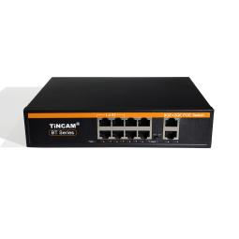 | TBC-PSD5510N | Full Gigabit 10-port POE switch: 8 Gigabit adaptive POE intelligent power supply interfaces (1-4 ports support BT60W) + 2 Gigabit uplink electrical ports, supporting international standard IEEE802.3 af/at/ bt, port power 30-60W, total power 120W; built-in power supply desktop structure 52V2.3A, size: 202*140*45mm
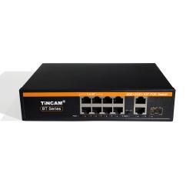 | TBC-PSD5511N-3PF | Full Gigabit 11-port POE switch: 8 Gigabit adaptive POE intelligent power supply ports (1-4 ports support BT60W) + 2 Gigabit uplink electrical ports + 1 Gigabit SFP optical port, supporting international standard IEEE802.3 af/at/ bt, port power 30-60W, total power 120W; built-in power supply desktop structure 52V2.3A, size: 202*140*45mm
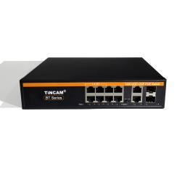 | TBC-PSD5512N-4PF | Full Gigabit 12-port POE switch: 8 Gigabit POE intelligent power supply ports (1-4 ports support BT60W) + 2 Gigabit uplink electrical ports + 2 Gigabit SFP optical ports, supporting international standard IEEE802.3 af/at/ bt, port power 30-60W, total power 120W; built-in power supply desktop structure 52V2.3A, size: 220*160*45mm
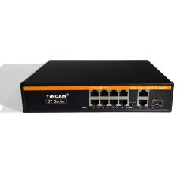 | TBC-PSD5511N20-3PF | Full Gigabit 11-port BT-POE switch: 8 Gigabit POE intelligent power supply interfaces (1-4 ports support BT60W) + 2 Gigabit uplink electrical ports + 1 Gigabit SFP optical port, support AI automatic detection function; support VLAN function; support long-distance power supply transmission; support international standard IEEE802.3 af/at/ bt, port power 30-60W, total power 200W; built-in power supply desktop structure, size: 220*160*45mm
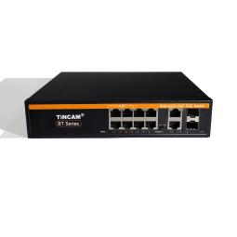 | TBC-PSD5512N20-4PF | Full Gigabit 12-port BT-POE switch: 8 Gigabit POE intelligent power supply ports (1-4 ports support BT60W) + 2 Gigabit uplink electrical ports + 2 Gigabit SFP optical ports, support AI automatic detection function; support VLAN function; support long-distance power supply transmission; support international standard IEEE802.3 af/at/ bt, port power 30-60W, total power 200W; built-in power supply desktop structure, size: 220*160*45mm

